

**GLOBAL FUND PROGRAM MANAGEMENT UNIT**

**COHORT TWO GROUP A NARRATIVE REPORT FOR AGYW MENTORSHIP PROGRAM**

**Instruction:**

|  |  |
| --- | --- |
| SR Name | GLOBCOM |
| DATE OF SUBMISSION | 1STDECEMBER2020 |
| REPORTED BY | NANCY ANYANGO ODHIAMBO  ANGELINE AKINYI OMWARE |
| COUNTY | SIAYA |
| SUB-COUNTY | ALEGO USONGA |
| WARD | NORTH ALEGO |
| VENUE | MBAGA MIXED PRIMARY SCHOOL AND SDA NORTH CHURCH |
| TARGET GROUP | 13-15 YEARS AGYWS |
| OBJECTIVES | * REDUCE HIV RISK AMONG AGYWS * IMPROVE SEXUAL AND REPRODUCTIVE HEALTH OUTCOME * SUPPORT STRATEGIES ON RETENTION OF ADOLESCENTS IN HIV CARE AND STRENGTHEN ADHERENCE |
| PROGRAM | MY DREAM BEYOND COVID-19 |

**Activity Details**

|  |  |  |  |
| --- | --- | --- | --- |
| Start Date  3/12/2020………………………………………… | | End Date  1/1/2021…………………………………………. | |
| Number of Mentor | 2 | | |
| Beneficiaries Reached  *(Who Completed All the Sessions)* | Female | | Male |
| C2GA 18 | | C2GA 7 |

Attendance by sessions: *This information should be from attendance registers*

|  |  |  |  |  |
| --- | --- | --- | --- | --- |
| **Session 1** | Date C2GA 3RD DECEMBER 2020…………………………………. | | | |
| Attendants | Female | C2GA 18 | Male | C2GA 7 |
| **Session 2** | Date C2GA 10TH DECEMBER2020…………………………………. | | | |
| Attendants | Female | C2GA 18 | Male | C2GA 7 |
| **Session 3** | Date C2GA 17TH DECEMBER 2020…………………………………. | | | |
| Attendants | Female | C2GA 18 | Male | C2GA 7 |
| **Session 4** | Date C2GA 24TH DECEMBER 2020……………………………………. | | | |
| Attendants | Female | C2GA 18 | Male | C2GA 7 |
| **Session 5** | Date C2GA 31ST DECEMBER 2020 | | | |
| Attendants | Female | C2GA 18 | Male | C2GA 7 |

**Introduction**

We first had a virtual training meeting at summit hotel for six consecutive days. We were taken through my dream beyond covid-19 program, its pillars and the basics of mentorship which were to be a guide on how to implement our sessions with the mentees. We were also introduced to the peer books which we were going to use.

**Mobilization**

After a successful meeting and roll out of the program by the organization on 27th November 2020 we were paired and allocated 300 mentees to be enrolled in a mentorship program in north alego.In this cohort we mobilized 75 mentees some from around Mbaga village, Kanungo village, Gombe, Nyakongo, Hono, Uranga and Banana village. We mobilized using school going AGYWs (by then class four and class eight pupils) to pass on information after being permitted by the school administration to do so and a church leader at Kanungo SDA north church who allowed us to pass the information during a church meeting. The exercise was completed successfully and we managed to get the required target of participants in this cohort.

**Methodology used**

The following materials were provided;

* Peer books
* Sticky notes
* Flipcharts
* Participants note books and pens
* Mark pens
* Session plan for the five sessions

During the five sessions; group activities, role plays, mini lectures, ice breakers, were used as a facilitation method as guided by the session plans

**Progress:**

**1. C2GA**

**a) Session one**

Introductions, expectations and introduction to sexual and gender based violence was our first session with the mentees which was held at Mbaga mixed primary school on 3RD DECEMBER 2020 as from 9.00am to 12.30am by mentors Nancy Anyango Odhiambo and Angeline Akinyi Omware.

**The topics discussed were:**

* Climate setting and introduction of mentees
* Introduction of my dream beyond covid -19
* Facilitator session (introduction of topic to mentees)
* Group work
* Brief on next session

We tackled all the topics and most mentees had heard about SGBV from other organizations and from their own parents which made it easier to introduce the topic. During group work we encouraged the mentees to present a small bit of what they had discussed in the group

**Session questions**

What does the law say about two minors engaging in sexual activities?

**b) Session two**

Introduction to sexual and gender based violence in our communities was our second session which was held at Mbaga mixed primary school on 10th December 2020 as from 9.00 am to 12.30 am by mentors Nancy Anyango Odhiambo and Angeline Akinyi Omware.

**The topics discussed were:**

* Recap of session one
* Facilitator session/group discussion topics and resource mapping activity
* Goal setting pillar: the rubber band activity
* Question and answer session (the questions the mentees dropped in the box during last question)
* Brief of the next session

We discussed all the outlined topics in detail and the mentees were tested by giving them group works which was presented during the session and a take home assignment which would be presented the next week by a representative from males and female. During the goal setting pillar topic the mentees drew a picture of what they wanted to become after showing them Andrew mulenga’s dream

**Session questions**

What is the difference between goals and dreams?

If not does not achieve their goals what can they do?

**c) Session three**

Rape and post rape medical emergency services was our third session which was held at Mbaga mixed primary school on 17th December 2020 as from 9.00 am to 12.30 am by mentors Nancy Anyango Odhiambo and Angeline Akinyi Omware.

**The topics discussed were:**

* Recap session and group task activity to compile the peer club vision board
* Facilitator session and group discussion
* Community action pillar: what can you change in your community?
* Questions and answer session (the questions that the mentees dropped in the box during the session
* Brief on next session

The recap session was done after which the outlined topics were well tackled and a take home assignment which would be presented the next week during recap session was given and we ended the session

**Session question**

In a case of rape how can a person say no?

**d) Session four**

Sexual reproductive health (SRH) information was our fourth session with the mentees which was held at Mbaga mixed primary school on 24TH December 2020 as from 9.00am to 12.30am by mentors Nancy Anyango Odhiambo and Angeline Akinyi Omware.

**The topics discussed were:**

* Recap session and group task activities
* Presentations on the discussions questions given in the previous session
* Question and answer session (the questions dropped in the box during last session)
* Brief of the next session
* Implementing community action pillar activity

All of the outlined topics were well discussed and the mentees were tested by giving them group works to do and present in class also a take home assignment which would be presented the next week during recap session was given. During the session the mentees implemented community action they picked rubbish around the nursery class we were using

**Session questions**

Does six pack also include in changes on boys during puberty?

Does homosexuality have to do with sexual reproduction hormones?

**e) Session five**

Life skills was our fifth and last session with the mentees which was held at Mbaga mixed primary school on 31ST December 2020 as from 9.00am to 12.30am by mentors Nancy Anyango Odhiambo and Angeline Akinyi Omware.

**The topics discussed were:**

* Recap session and introduction to life skills
* Facilitator session and group discussion
* Group work presentation recap on goal setting in relation to life skill and character formation
* Question and answer session (the questions that the mentees dropped in the box during the last session and any other questions that they have)
* Winding up session

Before the session we asked the mentees to appoint one male and one female both of who will present for us the recap session. All the questions the mentees asked were able to be addressed by their fellow mentees. During the session some of the mentees asked how they can manage to be assertive at all times as it was a challenging task more so when it came to friends.

**Session questions**

What is the difference between sympathy and empathy?

Why is it that when girls are assertive they are abused that they are proud?

**Challenges:**

**C2GA**

|  |  |
| --- | --- |
| **CHALLENGES** | **RESOLUTIONS** |
| Some mentees were shy and could not face their fellow mentees | We kept encouraging them to speak during recap sessions and taught them how good it is to have them boost self esteem |
| For the first session most of the mentees did not keep time as required | We had to discuss with them on the appropriate time to start session |

**Lesson Learnt:**

**C2GA**

* learnt that some of these mentees prefer use of vernacular during sessions as it helped them have a better understanding
* Another lesson we learnt is that creating a good rapport is important for this age group as their lively participation depends on how you started off with them,
* We also learnt that some of them their parents have warned them on issues pertaining gender based violence but a good number were not even aware that such thing exists

**Conclusion and Recommendations**

**C2GA**

**Conclusion**

We ended all our five sessions well and all of the mentees were happy with what we had taught them and the time we had spent with them. The fifth session was ended after a discussion on our next phase which was to be held on quarterly basis. As we were closing the intensive phase we ended with a vote of thanks from a male mentee and a female mentee and a brief talk from each of the mentors (Angeline Akinyi Omware and Nancy Anyango Odhiambo

**Recommendations**

* From mentees- these sessions should always be available all the times they close school as they at least keep them busy and equip them with good and productive image

**Success story**

In cohort two group a we had a participant who was too shy and could not face the class and her group during activities .she could not say a thing in class but we kept encouraging her .At times we could tell her to lead energizer sessions and fortunately by the third week she became strong and her self-esteem was boosted and she could now speak to other freely and socialize.

**Session photographs**

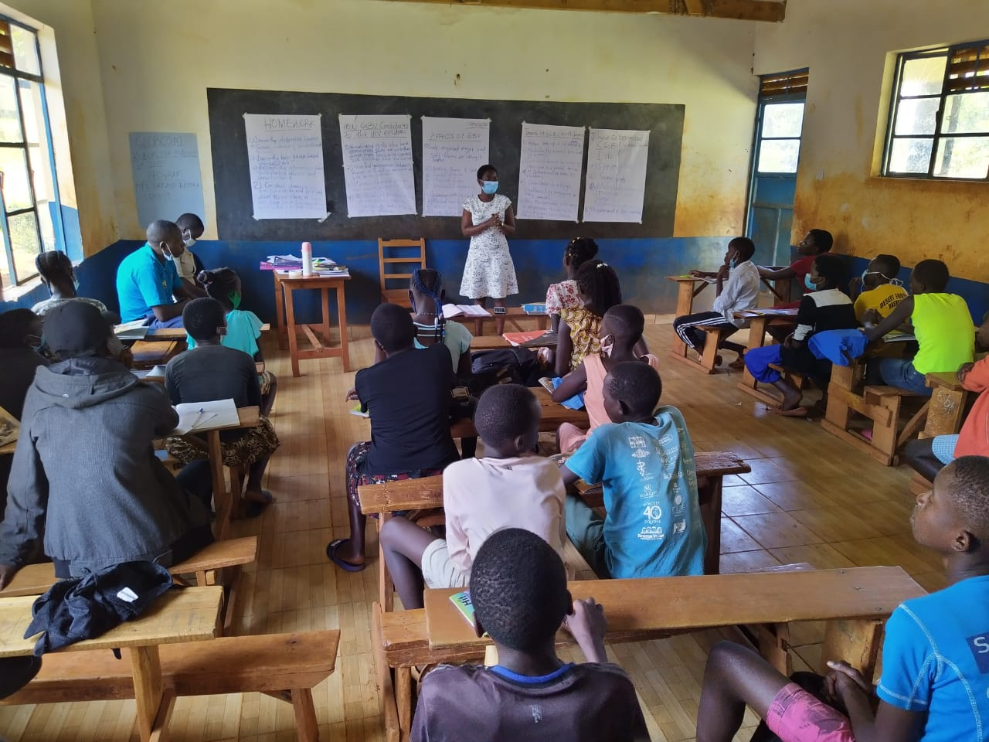

*Mentor Nancy Anyango giving a vote of thanks to the team that visited C2GA during session two at Mbaga mixed primary school on 10th December 2020*

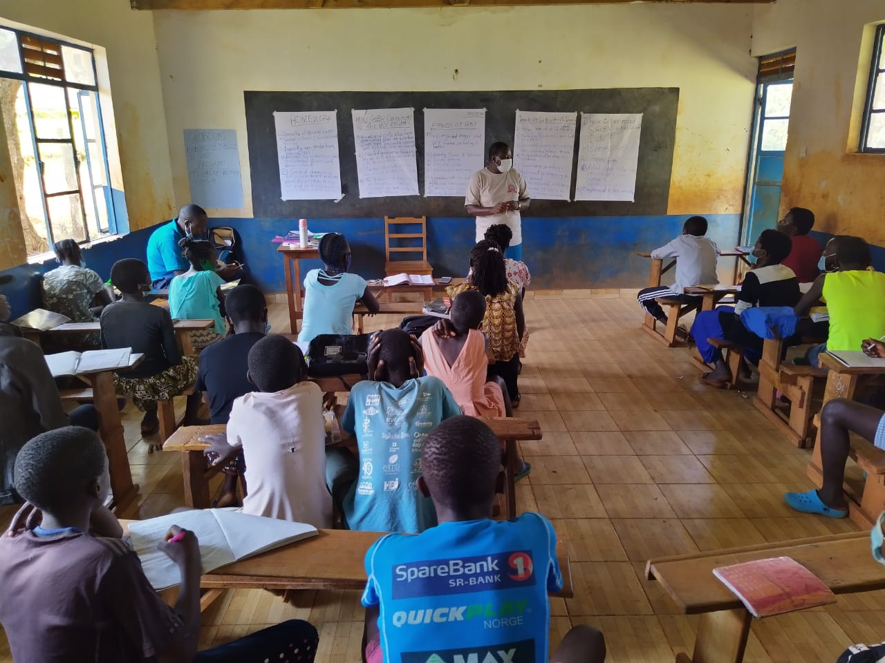

*SASCO addressing C2GA mentees during a visit from the ministry of health and globcom team at Mbaga mixed primary school on 10th December 2020*

***Name and Signature of Person compiling the Report***

|  |  |
| --- | --- |
| NANCY ANYANGO ODHIAMBO | 1ST DECEMBER 2020 |

***Name and Signature of Person approving the Report***

|  |  |
| --- | --- |
| BENSON OKOME | 1ST DECEMBER 2020 |